**Submit this page and the following pages for your OS Lab2 Assignment**

**Questions :**

1. Using your cheatsheet, find the IP address of your cloud VM.  
     
   IP Address _____10.1.6.144_____________________

Floating IP Address (if you have one) ________N/A______________

IPv6 Address _____2605:fd00:4:1000:f816:3eff:fe76:be4e________________

1. SSH into your server using Putty.
2. Find your current directory.  
     
   Current Directory __________/home/ubuntu___________________________
3. Find a file called “.profile” and view the contents. What word is at the beginning of the last line of the file ?  
     
   First word of the last line of .profile file ________________PATH____________
4. What command would you use to make the “Desktop” directory your current directory ?  
     
   __________________cd Desktop____________________
5. What command would you use to go back to the directory in step 3 ?  
     
   _____________________cd ..____________ ___
6. What command would you use to create a new directory (under your current directory) called “scripts” ?  
     
   _________________mkdir scripts__________________________
7. Change into your new directory (scripts) and copy your .profile file (from step 4) into your scripts directory. Write the successful command below.  
     
   ____________cp /home/ubuntu/.profile /home/ubuntu/scripts________________
8. Change the name of the *.profile* file (in scripts only !!) to *old_profile*. Write the command below.  
     
   _______mv .profile old_profile ___________
9. Copy *old_profile* to *new_profile*. Write the command below.  
     
   __________cp old_profile new_profile_______________________
10. Delete the *old_profile* file. Write the command below.  
      
    ________rm old_profile_____________________________
11. Take a screenshot of your Overview screen in the Cybera Rapid Access Cloud (RAC) and include it in this document for your submission.

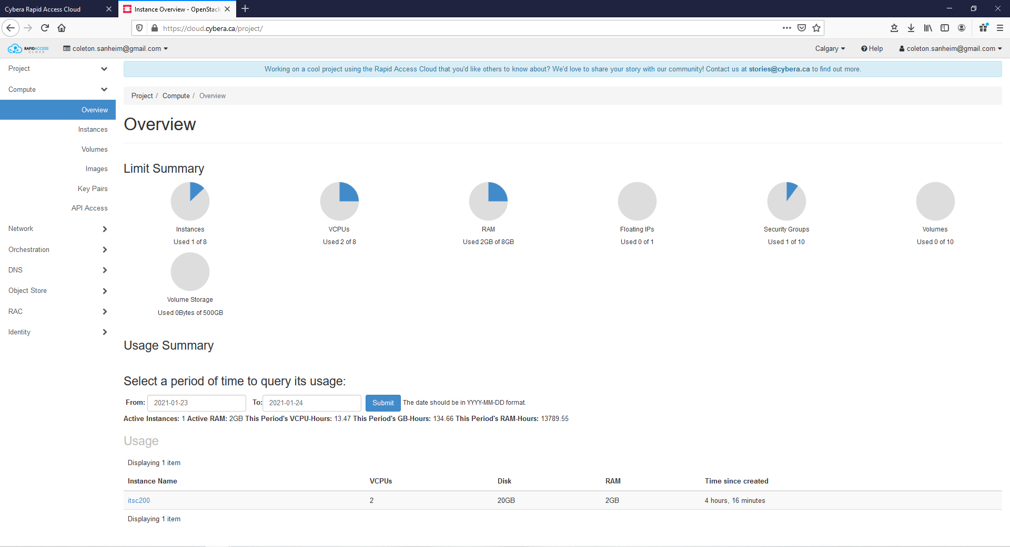

1. Log out of your VM and shut it down.
2. Release the floating IP address.